Daniel Albright

Semester Project

Dr. Carmen Astorne-Figari

May 8th, 2013

The Impact of Independence in Human Behavior in Evaluating Probability

The goal of this project was to discover whether or not people who observe independence were able to better update their beliefs than those who did not.

|  |  |
| --- | --- |
| **Roulette Board** | |
| **#** | **Color** |
| 3 | Red |
| 35 | Black |
| 20 | Red |
| 17 | Red |
| 31 | Black |
| 20 | Red |
| 21 | Red |
| 19 | Red |
| 9 | Red |
| 25 | Black |

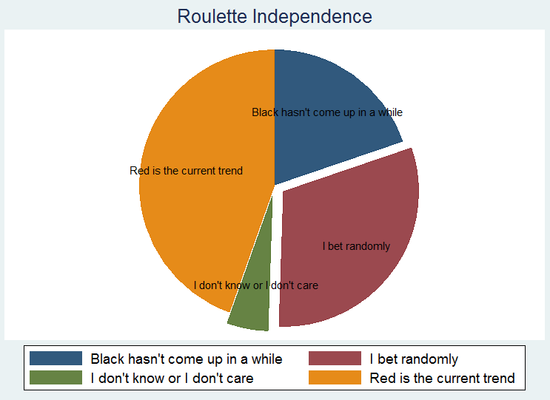We controlled for independence by presenting the subject with a board from a game of roulette similar to the ones displayed in casinos. It showed the last ten results of the wheel. In fact, casinos put this board into place specifically for people who do not observe independence. We then ask the subject to choose Black or Red. We are unconcerned with a specific number and are strictly interested in the subject’s observance of the color they choose as it’s a 50/50 probability. Then we ask her why she chose the color she did. The can answer from among (A) Red. “It is clearly trending.” (B) Black. “It hasn’t come up in awhile.” (C) “I chose randomly.” Or (D) “I don’t know” or “I don’t care.” If the subject answers A. or B. it is an indicator that she does not observe independence and we categorize her as such. If she chooses C. or D. then we categorize her as observing independence. D. We may prequalify D. as an indicator of independence because it doesn’t matter whether the subject *knows* about or is *conscious* of her observance independence, only that she acts in such a way. Roughly two-thirds of our sample chose the first two answers as for their reason in choosing their color.

We chose this method of eliciting the subject’s independence of actions in part because the probabilities matched the main experiment.

The experiment followed this. Under it, we directed the subject to correctly guess the outcomes from a device with a binary sample space, a coin, whose probabilities were unknown to them. In fact, the coin’s weight was set to 75% weighted towards the Heads side. There would be twenty repeated coin flips in which they were to call (guess) the flip (result) of the coin (the device). The results presented were the same given to everyone. To avoid variance in the x-bar and among the sequence output, we set the x-bar of the sequential outcomes presented to equal the mean. So in total there were 15 Heads and 5 Tails among the twenty outcomes presented to the subject and those sequences were identical and are shown below.

|  |  |  |  |  |  |  |  |  |  |  |  |  |  |  |  |  |  |  |  |  |
| --- | --- | --- | --- | --- | --- | --- | --- | --- | --- | --- | --- | --- | --- | --- | --- | --- | --- | --- | --- | --- |
| **Flip #** | **1** | **2** | **3** | **4** | **5** | **6** | **7** | **8** | **9** | **10** | **11** | **12** | **13** | **14** | **15** | **16** | **17** | **18** | **19** | **20** |
| **Result** | H | H | **T** | H | H | **T** | H | H | H | H | **T** | H | **T** | H | H | H | **T** | H | H | H |

This sequence of outcomes would occur in a *fair* coin only about 2% of the time. Yet, among the cross section of the sample, the observance of a bias towards Heads was not indicated, although it did tend to hover roughly around 60% in favor of Heads. One interesting side note, however, is that we observed ninety percent of our sample calling Heads for the first flip indicating it serves as a median choice among people, similar to the number 7 when choosing a number between one and ten.

Finally, we ended the experiment by asking the subject to evaluate what she believed the weighting of Heads to be after having observed the given sequence of outcomes: from 100% weighted towards head to 0% (or equivalent to being 100% weighted towards tails).

We drew our results from this but unfortunately, they were inconclusive for us. For instance, running a regression on the sample evaluation of the coin’s weighting of Heads to independence and other common demographics yielded the following. Demographics including education and the field of study (STEM, social sciences, humanities, and medicine) played little role in the Bayesian updating of the sample. However, our independence variable does show some significance as a correlation to the belief of the coin being biased towards Heads albeit with an unimpressive R-squared.

Source | SS df MS Number of obs = 356

-------------+------------------------------ F( 5, 350) = 3.80

Model | 1054.72181 5 210.944362 Prob > F = 0.0023

Residual | 19450.0507 350 55.5715733 R-squared = 0.0514

-------------+------------------------------ Adj R-squared = 0.0379

Total | 20504.7725 355 57.7599225 Root MSE = 7.4546

------------------------------------------------------------------------------

pctheads | Coef. Std. Err. t P>|t| [95% Conf. Interval]

-------------+----------------------------------------------------------------

independence | -3.176786 .8289675 -3.83 0.000 -4.80717 -1.546402

gender | -.5539174 .8626894 -0.64 0.521 -2.250625 1.14279

age | -.0470711 .0612756 -0.77 0.443 -.1675859 .0734436

education | -.0889437 .3282085 -0.27 0.787 -.7344528 .5565653

fieldofstudy | -.3232321 .2768011 -1.17 0.244 -.8676348 .2211705

_cons | 56.0815 1.938781 28.93 0.000 52.26837 59.89463

------------------------------------------------------------------------------

What is interesting is that they correlate in a way opposite to what we expected to observe. The histogram below shows that non-independent people updated better than independent people. 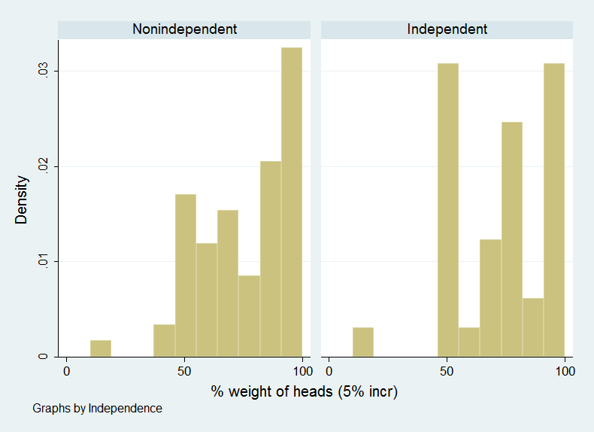

This indicates either of two problems with the experiment. Either we did not categorize people as independent correctly, or there is some other variable causing the results to skew opposite to what we’d expect.

The former is very possible when you consider that we may not yet know concretely about the subject’s observance and knowledge of independent trials from a probability device. For instance, the subject may *always* bet on Black regardless of the outcome and still observe independence, yet there actually wasn’t an answer for that reasoning among the choices. Thereby it may have inadvertently forced them to choose one of the answers we categorize as a non-independence indicator and thus incorrectly muddying the pool. In future experiments, it might be better to directly elicit this information.

Despite the experiment’s seemingly simple set up. There were perhaps many exogenous variables influencing their behavior in a manner that hindered us from seeing our expected results (if we were indeed meant to see them).

Even though the sequence of results given to the subject was static, the subjects as a whole may have been unduly influenced by the placement of the Tails result which may have served as some sort of reinforcement towards their belief that it was in fact a fair coin based on the result. This may have been a similar effect to loss aversion in which, while they may have initially picked up on heads being repeated, the sting of losing once one of the few Tails came up may have redirected their beliefs and accordingly, their behavior.

Other factors may have been the illusion of patterns. I had more than one subject say they chose heads or tails due to the belief that they had observed a pattern. It is common for humans to look for patterns when observing arranged information. Unfortunately, it is highly possible this had an effect.

In conclusion, there really isn’t one and what we have is something more of an anti-conclusion. The experiment seemed to propose more questions than was answered in large part due to the counter-intuitive results. The good news is that it yielded insight into how to further refine the experiment to run in a more precise fashion *and* it provided what could be topics for further research such as the observance of patterns as a factor in human decision-making in probabilistic scenarios.